SOCIAL MEDIA POST
Social media post to announce support for small businesses impacted by January 2026 Victorian bushfires

Channel | Post content | Hashtags/ profile tags
DJSIR LinkedIn | We’re supporting businesses across Victoria who have been affected by the summer 2026 bushfires.  Businesses in impacted areas can get free, one-on-one, confidential support from:  - Business Victoria’s Business Recovery Advisory Service: helping business owners to navigate the available supports and plan for long-term recovery.  - Small Business Financial Counselling: helping businesses who are in, or at risk of, financial hardship or emotional stress because of the bushfires.  The services are jointly funded by the Australian and Victorian Governments.  To find out more and to access these services, visit Business Victoria | #BusinessVictoria  #SmallBusiness

Image: Tiles created by BV team

Option 1: image is of the Walwa General Store
Can be downloaded here :
- https://business.vic.gov.au/__data/assets/image/0006/2455494/Business-Victoria_Instagram-Bushfire-Recovery-Support-2.png
- https://business.vic.gov.au/__data/assets/image/0008/2455496/Business-Victoria_Facebook_X-Bushfire-Recovery-Support-2.png

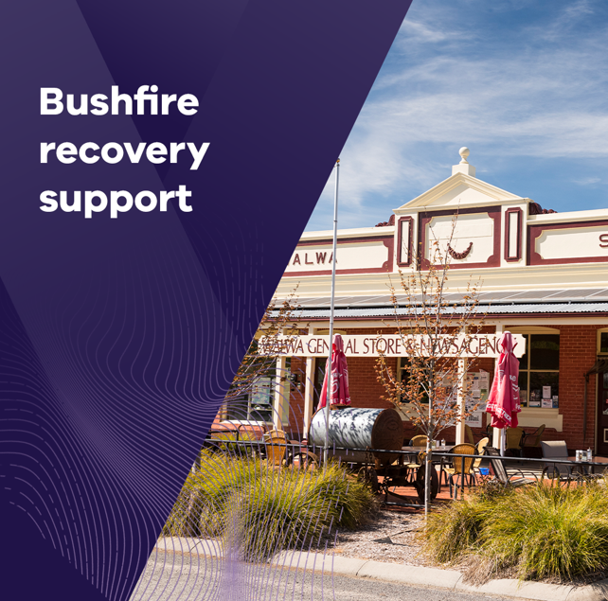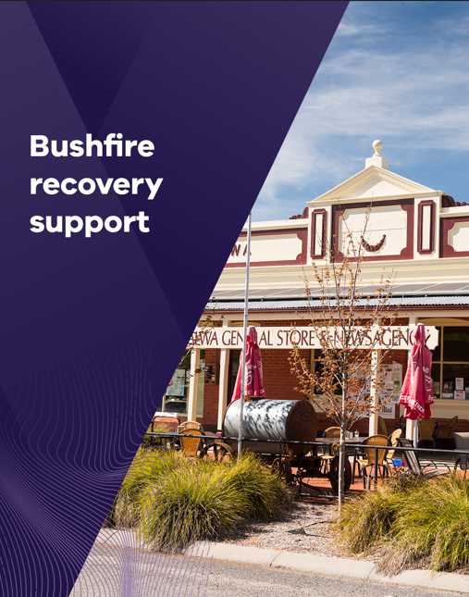

Option 2: image is of Forrest Brewing Company, Otway Ranges
Can be downloaded here :
- https://business.vic.gov.au/__data/assets/image/0010/2455498/Business-Victoria_Instagram-Bushfire-Recovery-Support.png
- https://business.vic.gov.au/__data/assets/image/0009/2455497/Business-Victoria_Facebook_X-Bushfire-Recovery-Support.png

