Skills Solutions Partnerships
Expression of interest guidelines

Table of Contents
1 Program summary 2
1.1 Overview 2
1.2 Program objective 2
1.3 End of program outcomes 3
1.4 Co-design 3
1.5 Priority sectors 3
1.6 Types of training 3
2 Applicant EoI commitments 3
3 Eligibility criteria 4
3.1 Eligible applicants 4
3.2 Ineligible applicants 4
4 Partnerships 4
4.1 Collaboration 4
4.2 Partner eligibility 4
5 Program timeline 5
6 Application process 5
6.1 How to apply 5
7 Assessment 5
7.1 Assessment criteria 5
7.2 Assessment process 6
7.3 Due diligence checks 6
7.4 Open and close dates 6
8 Notification of EoI outcomes 7
9 Compliance and audit 7
9.1 False or misleading information 7
9.2 Verification 7
10 Program evaluation 7
11 Privacy and confidentiality 7
12 Department probity and decision-making 7
13 Applicant conflict of interest 8
14 No right of appeal 8
15 Complaints 8
16 Further information 8

Program summary

Overview
The Skills Solutions Partnerships Program Round 2 (SSP) supports industry to partner with TAFEs and dual sector universities to design and pilot new short courses and on-the-job training to address skills gaps in priority sectors outlined in the Victorian Government’s Economic Growth Statement.
The Skills Solutions Partnership program is seeking Expression of Interest (EoI) applications from industry and TAFE or dual sector university partnerships interested in collaborating to co-design a new training solution to address a skills gap in one of the following sectors:
- Advanced manufacturing and defence
- Circular economy
- Agribusiness
- Health technologies and medical research
- Digital technologies
EoI applications will be competitively assessed by the Department of Jobs, Skills, Industry and Regions (the department), with successful applicants and their partners invited to participate in a co-design process over 4 weeks, to strengthen their shared understanding of the training gap, agree on a training solution, and scope a rapid pilot project that could be delivered to test the proposed solution.
Upon successful completion of the co-design process, partnerships will have the opportunity to apply for a grant of up to $500,000 (with funding to be matched by the project partners) to pilot their new training solution.
Grant applications will then be competitively assessed by the department, with successful pilot projects to be delivered by the end of May 2026 and project evaluation to be completed by the end of June 2026.
Table 1. SSP Program Stages
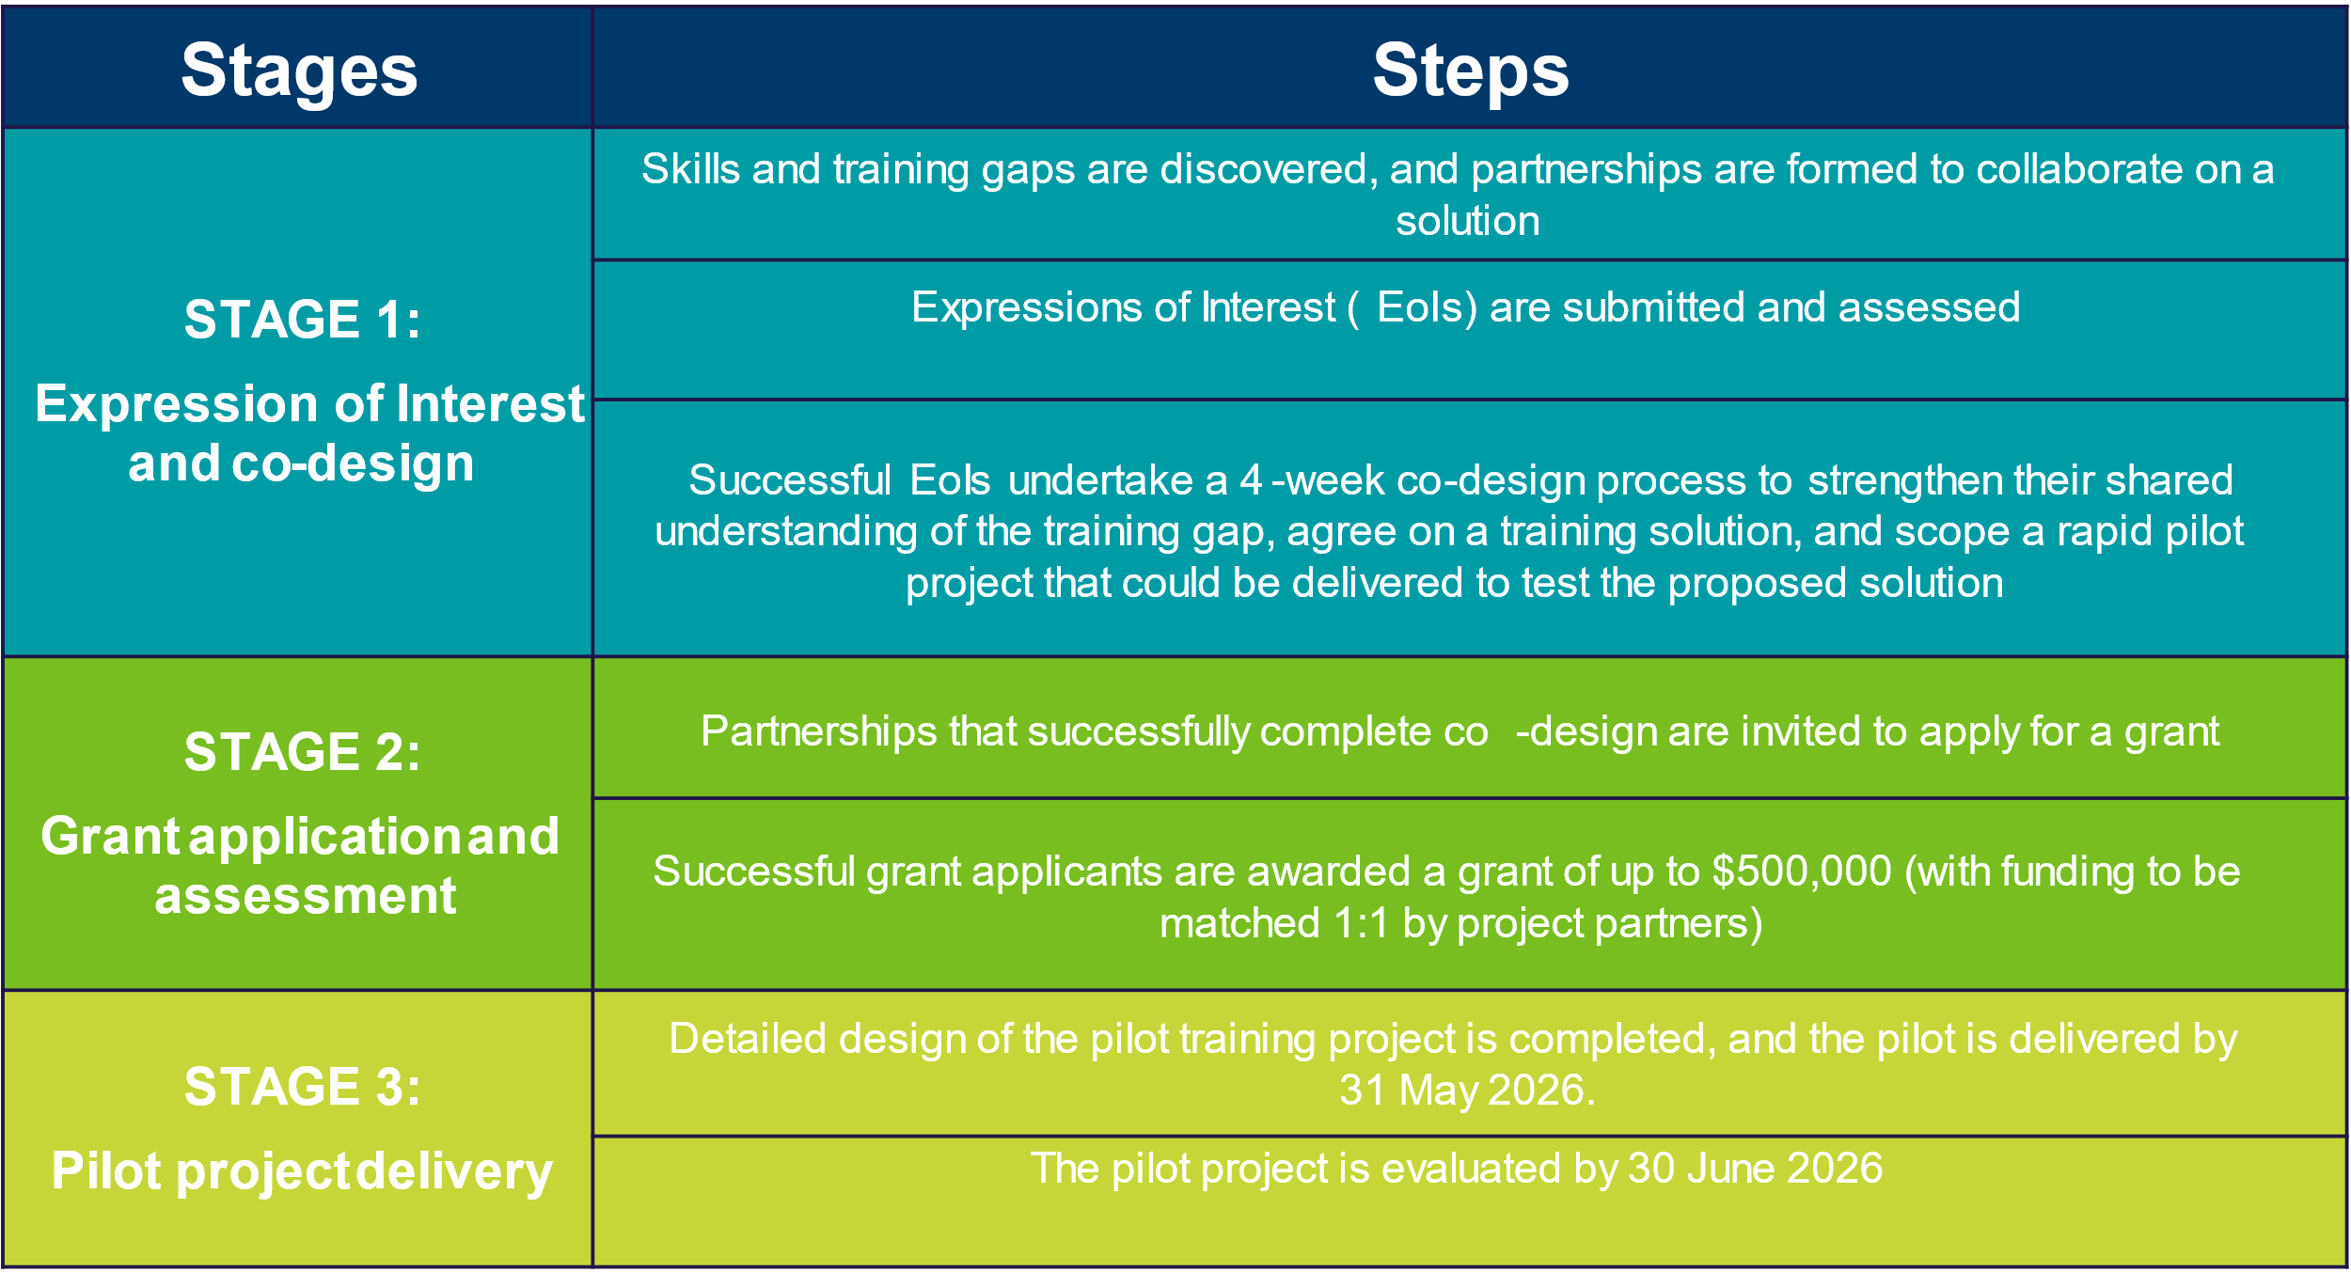

Program objective
The objective of the Skills Solutions Partnership program is to bring industry and TAFE or dual sector universities together to rapidly stand up new short courses and on-the-job training solutions that meet industry’s skilling needs in priority sectors.
It is anticipated that the Skills Solutions Partnership program will develop a new pipeline of industry endorsed training products that have the potential to be integrated into the training system, will benefit multiple businesses in the sector (or other sectors) and are scalable to support a significant number of workers.

End of program outcomes
The program aims to achieve the following outcomes:
- New or innovative training products have been rapidly delivered
- Industry in priority sectors has access to the workers they need to fill immediate skills gaps
- Partnerships have developed a collaborative model than can be adopted or adapted and scaled up to meet training needs across industry
- Insights from the program are informing the long-term response to skills shortages.

Co-design
The co-design process will be supported by an expert facilitator. Co-design is a useful process that enables project partners to share perspectives about the most critical skilling needs, workshop and agree on a preferred training solution, and rapidly scope a potential pilot project to test their solution.
It is expected that the co-design process will run for up to 4 weeks. The type of co-design will depend on the project needs and may range from facilitated workshops to meetings or roundtables.
At least one representative from each of the project partners is expected to participate in each of the co-design sessions. Other industry, government and training sector stakeholders may be invited by the department to participate in the co-design process to enrich the discussions as required.
At the conclusion of the co-design process, the facilitator will produce a report outlining the project partners’ recommended training solution and proposed pilot project.

Priority sectors
EoI applications addressing skills solutions supporting the 5 priority sectors outlined in the Victorian Economic Growth Statement are eligible to apply:
- Advanced manufacturing and defence
- Agribusiness
- Circular economy
- Health technologies and medical research
- Digital technologies.
It should be noted that applications are welcome from all five sectors, however preference will be given to advanced manufacturing and defence, circular economy and agribusiness sectors, unless applications from health technologies and medical research and digital technologies are compelling and score highly across all criteria. This acknowledges that 3 of the 6 successful projects under Skilled Solutions Partnerships Program Round 1 were health sector projects and that digital technologies will likely be an enabler for possible projects under Round 2.

Types of training
The following reskilling or upskilling training options are in scope:
- training at the Vocational Education and Training (VET) level or Higher Education level
- training that is accredited or non-accredited
- establishing new courses or modifying an existing course (such as updated content, new approach to incorporate on-the-job learning, an accelerated course)
- types of courses may be a micro-credential, skill set or other.

Applicant EoI commitments
Partners successful in their EoI application must commit to actively participate in the co-design process, including attending all workshops.
The co-design facilitation service costs will be funded by the department. Funding excludes the costs for participants’ attendance and any ancillary costs (e.g. staff salary, room hire, catering and participants’ travel costs are not paid for by the department).

Eligibility criteria

Eligible applicants
The lead applicant must meet the following criteria, as assessed by the department, to be eligible to apply:
- is a legal entity with an operating presence in Victoria
- has a current Australian Business Number (ABN) and held that ABN on and from 1 January 2022
- has been registered for Goods and Services Tax (GST) on and from 1 January 2022
- is one of the following:
  - a business industry group or professional association that has a direct role in supporting businesses in one of the eligible industry sectors in Victoria (as determined by the department)
  - a business leading on behalf of a group of businesses (such as a business with a large supply chain looking for joint training, or a business acting on behalf of a business network) located in Victoria
  - a TAFE or dual sector university headquartered in Victoria (and subject to the Education and Training Reform Act 2006).
- has met all industrial relations obligations as an employer in accordance with the National Employment Standards and holds a Victorian Government Fair Jobs Code pre-assessment certificate.

Ineligible applicants
The following entities are not eligible to apply:
- a Commonwealth department, agency or body
- Registered Training Organisations (RTOs)
- non-Victorian accredited dual sector universities and TAFEs
- a State department, agency, entity or other body established under the Public Administration Act 2004 (VIC) or equivalent legislation of another Australian jurisdiction
- unincorporated associations
- individuals/sole traders.

Partnerships

Collaboration
EoI applications are invited from partnerships of eligible businesses, industry associations, and Victorian TAFEs or dual sector universities. The partnership must include a Victorian TAFE or dual sector university. The partnership can be new or existing and with formal or informal arrangements.
Partnerships should include multiple businesses and/or an industry association representing multiple businesses to ensure broader impact across the relevant industry sector.

Partner eligibility
Through the EoI application, the lead applicant must identify the project partners and confirm that each meets the following eligibility:
- is a legal entity with an operating business presence in Victoria
- has a current Australian Business Number (ABN) and held that ABN on and from 1 January 2024
- has been registered for Goods and Services Tax (GST) on and from 1 January 2024
- has met all industrial relations obligations as an employer in accordance with the National Employment Standards and holds a Victorian Government Fair Jobs Code pre-assessment certificate.

Program timeline
The department is targeting the following indicative timeline:
Indicative Date | Activity
May 2025 | Program launched and EoIs open
June 2025 | EoIs for co-design close
July - August 2025 | Commencement of co-design processes for successful EoIs
September – October 2025 | Successful pilot projects confirmed and commence
May 2026 | Pilot projects completed
June 2026 | Pilot projects’ evaluations completed

Application process

How to apply
Applicants are required to submit an EoI via the online application form available on the Business Victoria website at www.business.vic.gov.au/ssp.
The EoI can only be made using this online form. Printed, facsimile, posted or other methods of delivery of the EoI form will not be accepted. All sections of the EoI form must be completed in full.

Assessment

Assessment criteria
EoI applications will be assessed against the following criteria:
Criteria | Weighting
Criterion 1: The project targets a critical skill gap in a priority sector
- Outline the skill gap that the proposed training solution will target and explain why these skills are required by industry. | 15%
- Provide evidence of the level of demand for the skill now and in the future. | 10%
Criterion 2: The project partners include an appropriate mix of businesses and/or industry associations in the sector and a TAFE or dual sector university
- Briefly describe the applicant’s and the project partners’ goods or services relevant to the proposed project. | 10%
- Briefly describe how you and your project partners will work together to maximise the impact of the co-design process. | 5%
Criterion 3: The project proposes a new or innovative training solution that has potential to be integrated on a sustainable basis into the training system
- Briefly explain why existing training offerings do not meet industry needs, with reference to any relevant courses currently offered in the market. | 10%
- Outline the proposed training solution and on-the-job learning model and explain how this solution is new or innovative. | 10%
- Outline how the training solution could be funded after the pilot. | 5%
Criterion 4: The proposed training solution has the potential to benefit Victorian workers
- Outline:  - the participants that will benefit from the proposed training  - how many participants are anticipated to be trained in the pilot  - what, if any, prior qualifications participants are likely to hold. | 10%
- Briefly explain how the new skills developed will benefit participants in their workplace, now and into the future. | 10%
Criterion 5: The proposed training solution has the potential to benefit multiple businesses in priority sectors
- Detail how the training could be scaled up after completion of the pilot to benefit a significant number of workers and multiple businesses in the sector, and other sectors if applicable. Include estimates and evidence of the numbers. | 15%

Assessment process
Successful EoI applicants will be required to rate highly against the program assessment criteria compared to other eligible applicants.
- Applications will be assessed against the eligibility criteria and priority sectors.
- All supplementary attachments and information provided as part of the application will be taken into consideration during the assessment process.
- Eligible applications will be assessed against the assessment criteria (at section 7.1) by an assessment panel that includes department staff and may include external assessors and/or industry experts.
- Applications may undergo due diligence checks
- In making final recommendations, the department will take into consideration priority industry sectors (as outlined at Section 1.5.

Due diligence checks
Applicants may be subject to due diligence checks to enable the department to assess financial and other non-financial risks associated with the application.
Such checks may include:
- the potential for reputational risk to the State
- the risk profile, financial viability and management capacity of the applicant’s business over the duration of the proposed activity
- whether the proposal has received funding through other means
- the delivery performance of other grants contracted with the Victorian Government and whether the applicant has failed to meet key contractual obligations
Outcomes from such assessments may be taken into account in any decision to recommend or award a grant and in contracting with successful applicants.
The department may, at any time, remove an applicant from the application and assessment process, if in the department’s opinion, association with the applicant may bring the department, a minister or the State of Victoria into disrepute.

Open and close dates
EoI applications open on Friday 16 May 2025 and will be accepted until 23:59pm (AEST) on Friday 27 June 2025 (unless funds are allocated earlier).
Applications can be made via the online application form available on the Business Victoria website at www.business.vic.gov.au/ssp.
Further information is available on the SSP website: www.business.vic.gov.au/ssp

Notification of EoI outcomes
Applicants will be advised of the outcome of their EoI application via email.
If successful, applicants will be issued a letter of offer inviting them to undertake a co-design process.

Compliance and audit

False or misleading information
If any declaration or statement made or information provided by the applicant is found to be incomplete, inaccurate, false or misleading, the EoI application may not be approved.

Verification
The applicant acknowledges that as part of the assessment process, evidence provided by the applicant will be subject to verification by the department.

Program evaluation
Successful applicants will be required to participate in any evaluation activities initiated by the department, including ensuring the participation of partners. This may include completing surveys at the conclusion of the co-design process to measure program outcomes. Non-compliance could impact future applications to the department’s programs.
Reporting is critical to the department in understanding program impact, supporting continuous improvement in program design and delivery, and delivering more effective grant programs for all Victorians.

Privacy and confidentiality
Any personal information provided will be collected and used by the department for the purposes of assessing eligibility, providing feedback to applicants, program administration, program review and evaluation.
The department completes a range of eligibility assessments that may include data matching to clarify the accuracy and quality of information supplied. This is part of our auditing and monitoring processes and for confirming eligibility across this program.
In assessing an application as well as in any audit or evaluation of a successful grant, it may be necessary to share personal information with State and Commonwealth Government departments and agencies, as well as other external experts. If personal information about a third party is included in the application, the applicant must ensure the third party is aware of and consents to the contents of this privacy statement.
The department collects demographic information for economic reporting purposes. No personal information is used in reporting; all reports are presented with aggregated data.
Any personal information about the applicant or a third party will be collected, held, managed, used, disclosed or transferred in accordance with the provisions of the Privacy and Data Protection Act 2014 (Vic) and other applicable laws.
Enquiries about access or correction to your personal information, can be emailed to skillssolutions@ecodev.vic.gov.au.
Other concerns regarding the privacy of personal information, can be emailed to the department’s Privacy Unit at privacy@ecodev.vic.gov.au. The department’s privacy policy is also available by emailing the department’s Privacy Unit.

Department probity and decision-making
The Victorian Government makes every effort to ensure the EoI application and assessment process is fair and undertaken in line with the published program guidelines.
Decisions are at the discretion of the minister and the department.
These guidelines may be changed from time to time, at the discretion of the department and the changes will apply to your application.
Decisions in recommending and awarding grant funding under this program are at the department discretion. This includes not making any funding available or approving a lesser amount than that applied for.
The department may request the applicant provide further information should it be necessary to assess an application to the Skills Solutions Partnerships policy objectives.
Victorian Government staff are required to act in accord with the Code of Conduct for Victorian Public Sector Employees (Section 61) issued under the Public Administration Act 2004 (Vic). This includes an obligation to avoid conflicts of interest wherever possible and declare and manage any conflicts of interest that cannot be avoided.

Applicant conflict of interest
A conflict of interest arises where a person makes a decision or exercises a power in a way that may be, or may be perceived to be, influenced by either material personal interests (financial or non-financial) or material personal associations. A conflict of interest may arise where an applicant:
- Has a professional, commercial, or personal relationship with a party who is able to, or may be perceived to, influence the application assessment process, such as a Victorian Government staff member
- Has a relationship with, or interest in, an organisation which is likely to interfere with or restrict the applicant from carrying out the proposed activities fairly and independently.
Applicants must advise the department of any actual, potential, or perceived conflicts of interest relating to a project for which it has applied for funding.

No right of appeal
A decision in relation to an application is not subject to review or appeal of any kind. Applicants may request feedback from the department on their application.

Complaints
If an applicant wants to lodge a complaint or provide feedback to the department about the process for a grant application, requests can be made via this online form, by sending a written request to skillssolutions@ecodev.vic.gov.au.
Requests can be made in relation to the application process and adherence to these guidelines. Re-assessment of an application or overturning of a funding decision for a merit-based grant, will not be considered through the complaints process.
Once your complaint has been received by the department, it will be acknowledged within 2 working days and provided to the review team to be resolved.
Your complaint will be resolved within 28 business days unless further investigation is required. If further investigation is required, you may be contacted by phone or email asking for additional information.

Further information
Further information can be found on the SSP website: www.business.vic.gov.au/ssp.
Details of online information sessions will be published on the website.
For email inquiries relating to the program, email skillssolutions@ecodev.vic.gov.au.

