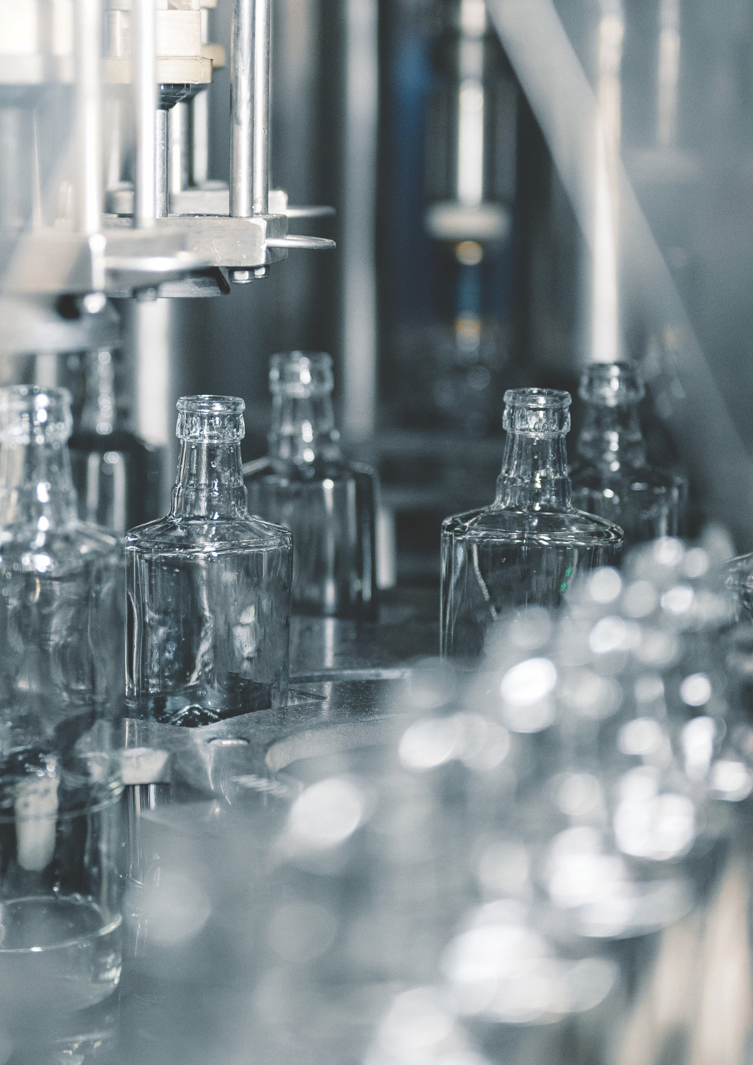

Distillery Support

Safety – Hazardous Areas and Dangerous Goods

Rebate

|  |
| --- |
| Acknowledgment  We acknowledge and respect Victorian Traditional Owners as the original custodians of Victoria's  land and waters, their unique ability to care for Country and deep spiritual connection to it. We  honour Elders past and present whose knowledge and wisdom has ensured the continuation of  culture and traditional practices.  We are committed to genuinely partner, and meaningfully engage, with Victoria's Traditional Owners  and Aboriginal communities to support the protection of Country, the maintenance of spiritual and  cultural practices and their broader aspirations in the 21st century and beyond. |
| © The State of Victoria Department of Energy, Environment and Climate Action 2023  LogoThis work is licensed under a Creative Commons Attribution 4.0 International licence. You are free to re-use the work under that licence, on the condition that you credit the State of Victoria as author. The licence does not apply to any images, photographs or branding, including the Victorian Coat of Arms, the Victorian Government logo and the Department of Energy, Environment and Climate Change (DEECA) logo. To view a copy of this licence, visit <http://creativecommons.org/licenses/by/4.0/>  Disclaimer  This publication may be of assistance to you but the State of Victoria and its employees do not guarantee that the publication is without flaw of any kind or is wholly appropriate for your particular purposes and therefore disclaims all liability for any error, loss or other consequence which may arise from you relying on any information in this publication.  Accessibility  If you would like to receive this publication in an alternative format, please contact the grants administrator [distilleryprogram@agriculture.vic.gov.au](mailto:distilleryprogram@agriculture.vic.gov.au). |

Contents

What is the Distillery Door Program? 4

What is the Hazardous Areas and Dangerous Goods Rebate? 4

Why focus on Safety - Hazardous Areas and Dangerous Goods? 5

What are the program dates and application process? 5

Who is eligible to apply? 6

Who is not eligible? 7

What might be funded? 7

What will not be funded? 8

What supporting documents will need to be provided? 9

Tax implications 10

Absolute discretion 10

Publicity 11

Privacy 12

Further information 12

# What is the Distillery Door Program?

The 2021-22 Victorian Budget included a commitment to deliver the Distillery Door Program (the Program), with $10 million total funding over 2 years to support and enhance Victoria’s distillery industry. A further $10 million was included in the 2023-24 Victorian Budget to continue to build on the existing program.

The Program has been co-designed by the Victorian Government and industry to support and enhance Victoria’s distillery industry through supporting skills development, boosting the visitor economy, infrastructure and safety, and export capability.

Work is underway in all streams of delivery, including the recent grant program which focused on boosting the visitor economy and infrastructure. Over $5.3 million was approved to eligible distillers.

# What is the Hazardous Areas and Dangerous Goods Rebate?

The Hazardous Areas and Dangerous Goods Rebate will assist distillers of alcoholic beverages to invest in equipment and infrastructure to improve safety in distilleries.

A Rebate of up to 70% or 80% of the total eligible expenditure (GST exclusive) or up to the maximum of $50,000 (GST exclusive), whichever is the lesser amount, is available for equipment and infrastructure that will support improvements to safety in distilleries.

Applicants will be required to make a cash co-contribution of a minimum of 20% or 30% of the total eligible expenditure on infrastructure and equipment on the project.

Co-contribution will be:

* 20% cash co-contribution if no more than 10,000 litres of alcohol produced in the 2022-23 financial year
* 30% cash co-contribution if greater than 10,000 litres of alcohol produced in the 2022-23 financial year

Co-contributions must be cash. In-kind contributions such as labour are not included. Any additional or ineligible costs associated with the overall project must be met by the applicant.

# Why focus on Safety - Hazardous Areas and Dangerous Goods?

All distilleries have safety obligations under the Occupational Health & Safety Act 2004 (OHS Act) to ensure a safe working environment. As the industry grows it is critical that distilleries are supported to understand how to ensure safety is being managed appropriately.

Ethanol is the primary material used in distilled spirits manufacturing and is a flammable Dangerous Good. There have been multiple accidents at distillery sites due to the manufacture, storage and handling of ethanol as part of operations. Dangerous Goods need to be handled in a safe manner to minimise the likelihood of an accident, causing damage to personnel, plant or the business.

Hazardous Areas are established when working with flammable liquids to reduce the likelihood of ignition sources in an area that may have an explosive atmosphere due to the presence of ethanol vapour. These areas are important to define what equipment and processes are suitable for use in these environments to reduce the risk of incident.

There are requirements for the storage and handling of dangerous goods under the OHS Act and Dangerous Goods Act 1985, the Dangerous Goods Regulations 2022 and the relevant Code of Practice: Relevant standards that provide the required level of protection include AS1940 Flammable Liquids Storage & Handling and AS/NZS 60079.10.1 2022 (Explosive atmospheres classification of areas - Explosive gas atmospheres).

# What are the program dates and application process?

Please ensure you read these Program guidelines thoroughly. Applications must be submitted online via the Agriculture Victoria [website](https://agriculture.vic.gov.au/support-and-resources/funds-grants-programs/distillery-support-infrastructure-boosting-visitor-economy) by 5.00 pm on 30 September 2024 or until funds are fully subscribed (whichever occurs first).

Applicants will need to provide details of eligibility as detailed in the *Who is eligible to apply?* section and attach the relevant supporting documentation as listed on page 9.

Applicants will be advised in writing via email of the outcome of their application within 3 weeks of lodgement.

# Who is eligible to apply?

To be eligible, you must:

1. Have a current Australian Business Number (ABN)
2. Be registered as a business in Victoria
3. Be a legal entity[1]
4. Own at least one still with a capacity of 50 litres or more
5. Hold a current ATO Manufacturer’s Licence to produce distilled alcoholic beverages
6. Hold a current Victorian General or Producer’s Liquor Licence issued by Liquor Control Victoria
7. Have had a Hazardous Area Assessment, Dangerous Goods Audit, OHS Essentials Program relating to hazardous areas and dangerous goods, or assessment by a Worksafe dangerous goods inspector – undertaken from 1 April 2023 until closing date
8. Be able to meet the cash co-contribution (minimum 20% or 30%) required
9. Agree to participate in future Program evaluation activities
10. Meet all workplace and employment obligations as an employer in accordance with the National Employment Standards and the rights and obligations under applicable industrial awards

Applicants will need to:

1. Meet the general eligibility criteria for the Rebate
2. Attest to litres of distilled alcohol produced in the 2022-23 financial year
3. Provide copies of their current ATO Manufacturer’s Licence to produce distilled alcoholic beverages and their current Victorian General or Producer’s Licence
4. Provide a copy of one of the following: Hazardous Area Assessment, Dangerous Goods Audit, OHS Essentials Program relating to hazardous areas and dangerous goods, or assessment by a WorkSafe dangerous goods inspector – undertaken from 1 April 2023 until closing date
5. Provide copies of invoices and receipts for eligible items
6. Provide a Statutory Declaration attesting to the total costs

# 

# Who is not eligible?

You are not eligible to apply if you are:

1. A producer of spirits that does not distil their own alcoholic beverages
2. A state government department, agency or local council
3. An unincorporated association or franchise
4. A potential applicant who has applied for another state government grant for the same project
5. Not based in Victoria

# What might be funded?

This program may provide a Rebate up to the value of $50,000 (GST exclusive) of eligible costs associated with one or more of these activities:

* 1. Costs associated with having a Hazardous Area Assessment or Dangerous Goods Audit undertaken from 1 April 2023 until closing date
  2. Purchase and installation of equipment and infrastructure as recommended in either the Hazardous Area Assessment, Dangerous Goods Audit, OHS Essentials Program relating to hazardous areas and dangerous goods, or assessment by a Worksafe dangerous goods inspector from 1 April 2023 until closing date
  3. Training specific to the technology for safe operation of equipment recommended (external costs only)

All funded activities must comply with Australian Standards (including installation) where required by regulation. Installations must comply with the manufacturer’s instructions and use licensed tradesmen when required by legislation, council regulation or the manufacturer’s instructions. This is the responsibility of the recipient; the Department is not liable in any way in relation to or in connection with the project, other than as expressed in these Guidelines.

As this is a Rebate program, all costs must be incurred before applying. If you have any concerns about item eligibility, please contact the Distillery Door Program team at [distilleryprogram@agriculture.vic.gov.au](mailto:distilleryprogram@agriculture.vic.gov.au) **PRIOR TO** making your purchase.

There is no guarantee that any application for a Rebate will be supported.

# What will not be funded?

1. New or replacement stills
2. Items not recommended in either the Hazardous Area Assessment, Dangerous Goods Audit, OHS Essentials Program relating to hazardous areas and dangerous goods, or assessment by a Worksafe dangerous goods inspector
3. Items pertaining to brewing, wine making and other beverage production
4. Motorised transport vehicles (eg. forklifts, trucks, utes, etc) or vehicle associated costs
5. Routine maintenance costs
6. Internal costs, salaries or resources of the Recipient
7. Fees associated with permits for planning or annual certification
8. Costs associated with applying for government grants and funding programs
9. Basic professional services such as ongoing, routine accounting, tax and legal business requirements, licensing, legal/intellectual property costs, financing fees
10. Travel costs
11. Any administrative fees or surcharges for administering the expenditures listed above; or
12. Any other expenditure as determined by the Department that does not meet the Program guidelines or objectives.

Any ineligible expenditure associated with the overall project must be met by the recipient.

.

# What supporting documents will need to be provided?

Please provide relevant documents to support your application.

A maximum of **eight** documents can be uploaded. This includes:

|  |  |
| --- | --- |
| **Document Type** | **Notes** |
| Licences | Copy of:   * ATO Manufacturer’s Licence to produce distilled alcoholic beverages * Victorian General or Producer’s Liquor Licence issued by Liquor Control Victoria |
| Distillery Assessment | Copy of either your:   * Hazardous Area Assessment * Dangerous Goods Audit * OHS Essentials Program assessment relating to hazardous areas and dangerous goods * Assessment undertaken by a Worksafe dangerous goods inspector   undertaken from 1 April 2023 until closing date |
| Invoices and Receipts | Copy of all invoices and receipts for eligible expenditure undertaken from 1 April 2023 until closing date |
| Statutory Declaration | A Statutory Declaration attesting to the total costs |

If there is insufficient space to upload all attachments, please email them separately to [distilleryprogram@agriculture.vic.gov.au](mailto:distilleryprogram@agriculture.vic.gov.au) quoting your GA number. The GA number will be provided when you save your application form on the portal.

# Tax implications

Applicants should consult the Australian Taxation Office or seek professional advice on any taxation implications that may arise from this Rebate.

Successful applicants without an ABN will need to provide a completed Australian Taxation Office form ‘Statement by a Supplier” so that no withholding tax is required from the Rebate payment.

# Absolute discretion

The Department’s decisions on all matters pertaining to the award of a Rebate under this Program is at the Department’s absolute discretion. This includes approving a lesser amount than that applied for.

The Department reserves the right to request the applicant provide further information should it be deemed necessary.

The Department reserves the right to amend these guidelines and the application terms at any time as it deems appropriate in its absolute discretion.

The Department makes no representation that a Rebate will be made to any applicant and reserves the right to make no funds available under the Program.

All costs in connection with this application are the responsibility of the applicant.

# Publicity

Rebate recipients may be asked to assist the Department in promotion of the Program. This may include involvement in media releases, case studies or promotional events and activities.

The Department may request recipients to fact check any text and seek approval to use any owned imagery associated with the project prior to the publication of any such promotional materials.

Recipients must not make any public announcement or issue any press release regarding the receipt of a Rebate without prior written approval from the department.

The Department may publicise the benefits accruing to the successful applicant and/or the State associated with the provision of the Rebate and the State’s support for the Project. The Department may include the name of the recipient and/or Rebate amount in any publicity material and in the Department’s annual report.

If requested by the Department, the recipient must ensure that the State’s support for the Rebate is acknowledged on all promotional materials and appropriate signage (available at www2.delwp.vic.gov.au/grants) or as otherwise specified by the Department.

# Privacy

Any personal information about you or a third party in your application will be collected by the department for the purposes of administering your grant application and informing Members of Parliament of successful applications. Personal information may also be disclosed to external experts, such as members of assessment panels, or other Government Departments for assessment, reporting, advice, comment or for discussions regarding alternative or collaborative grant funding opportunities. If you intend to include personal information about third parties in your application, please ensure that they are aware of the contents of this privacy statement.

Any personal information about you or a third party in your correspondence will be collected, held, managed, used, disclosed or transferred in accordance with the provisions of the *Privacy and Data Protection Act 2014* and other applicable laws.

DEECA is committed to protecting the privacy of personal information. You can find the DEECA Privacy Policy online at www.delwp.vic.gov.au/privacy.

Requests for access to information about you held by DEECA should be sent to the Manager Privacy, P.O. Box 500 East Melbourne 8002 or contact by emailing [Foi.unit@delwp.vic.gov.au](mailto:Foi.unit@delwp.vic.gov.au).

# 

# Further information

If you require assistance submitting your application online, email [grantsinfo@delwp.vic.gov.au](mailto:grantsinfo@delwp.vic.gov.au).

Additional information about the Distillery Door Program can be found on our [website](https://agriculture.vic.gov.au/support-and-resources/funds-grants-programs/distillery-support-infrastructure-boosting-visitor-economy) or by contacting:

Agriculture Victoria

Department of Energy, Environment and Climate Action

Tel: 1300 502 656

Email: [distilleryprogram@agriculture.vic.gov.au](mailto:distilleryprogram@agriculture.vic.gov.au)

1. A legal entity is an association, corporation, trustee of a trust, or individual that has legal standing in the eyes of the law. A legal entity has legal capacity to enter into agreements or contracts, assume obligations, incur and pay debts, sue and be sued in its own right, and to be held responsible for its actions.