How to structure content on your website pages for optimal SEO outcomes.

## Writing content for your website

Search engines look at the structure of each page on your website. Each page is awarded *relevance & rank* on search enginesfor a specific topic or key phrase based on certain details of the page structure. Keep in mind the following concepts when writing for the pages.

### Page Title (used for search engines)

To explain some of the concepts in this document we will refer to a single page on the Business Victoria website [Eight steps to website success](http://www.business.vic.gov.au/marketing-sales-and-online/online-business-and-technology/how-to-build-a-website/eight-steps-to-website-success)

### Page Title (used for search engines)

Your *page title* is the most important SEO element. It should be natural and relate to the content on the page. The ideal count for a *page title* is between 50 - 60 characters long.

For example, the page title should be:

### Eight steps to website success | Business Victoria

**Tip:** You can use a preview tool to see if your title will fit correctly on search engine results page. Here is an example of a [Title tag preview tool](http://moz.com/blog/new-title-tag-guidelines-preview-tool)

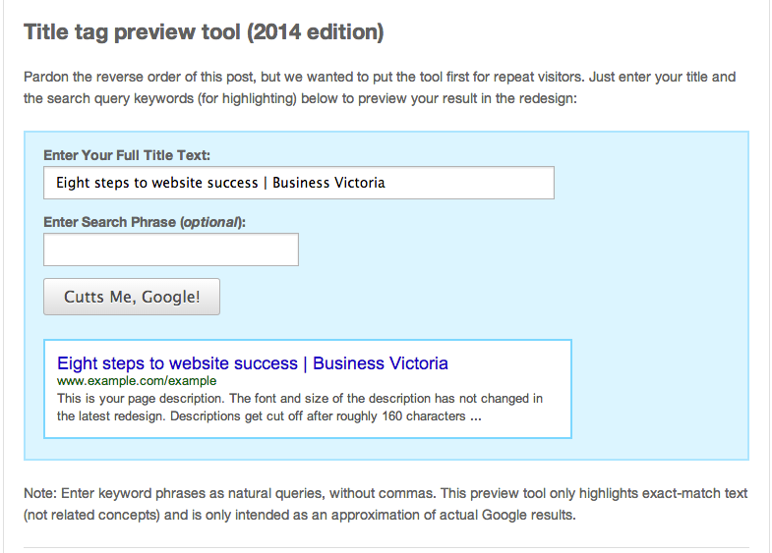

### Page Descriptions (used for search engines)

Your *page description* is the second most important SEO element. Like the *page title* it should be natural and relate to the content on the page. The ideal count for a *page description* is between 130 – 160 characters long.

For example, the page description should be:

**Build a successful website with these eight tips on researching the right design and build for your site and mapping your content.**

Please note that this content is not visible to users on the web page and only shows up below search engine results, and when the page is shared on social media. Google will sometimes disregards a page description and shows its own based on the words put in the search box.

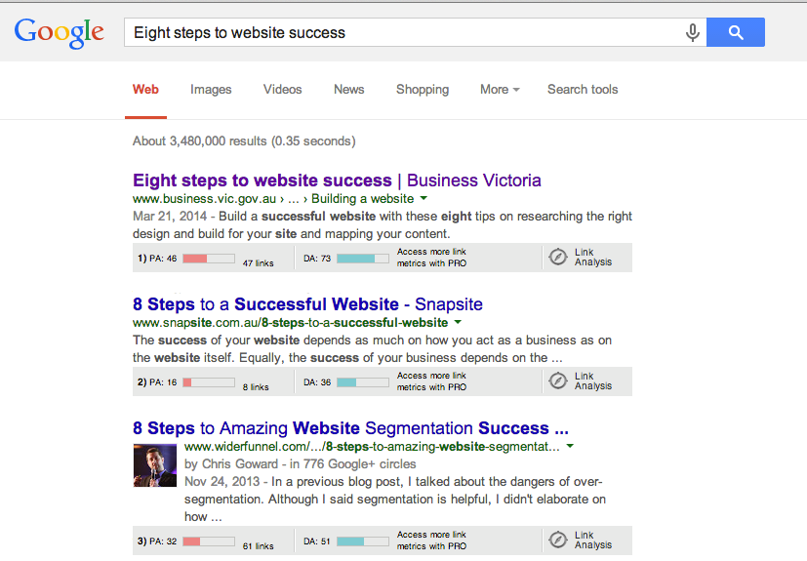

## Page content

Below are some key recommendations when writing content for website pages.

### Main title

Always ensure the page title is clear and easy to understand. For example, in the Business Victoria page the title is:

### Eight steps to website success

This title is clear and easily understood by both users and search engines.

**Note:** Ensure all main page titles on your website are wrapped in a H1 tag. If you are using a CMS (Content Management System, e.g. Wordpress) with a WYSIWIG (What You See Is What You Get) editor, simply select the Heading 1 option after selecting the page title. The process might be different based on the platform but most major CMS providers will allow you to easily do this on each of the pages.

If you are unsure how to use this function in your CMS, try searching in the help section of the provider.

### Sub headings

Use sub headings for the different pieces of content that will go on the website page. For example, the pages’ main sub – heading is:

**Build a quality website to find new customers and boost business.**

Some of the secondary headings include:

* **Get planning**
* **Choose the build**
* **Research website building platforms**

**Search engines will read these subheadings, and it will also make it easier for your audience to digest the content.**

### Keywords and key phrases on top

It is recommended to use the target keywords in the first 200 words of the web page content. Putting keywords early in the content emphasizes that the web page content is about that keyword. Search engines and users look positively towards web pages that have the related keywords higher up the page.

**Note:** The content has to sound natural. ‘Stuffing’ keywords into the first 100 words of the web page may actually cause the page to be penalised by search engines and disliked by users.

### Break content up

Try to break up content in smaller chunks of text as opposed to one big chunk. By breaking up content users are more to read the text and take the desired action at the end of it. For example, click on the button to contact or find more information.

**Note:** To break up the content use bullet lists and numbered lists. Bold text and italics are also important and should be used throughout the content.

On the Business Victoria web page, content has been broken up with numbers and bullet points so that it is easily digestible.

### Use images & videos

Videos and images are another good way to break up content. Engaging images and videos help with conversation rates on the website and are likely to get visitors more involved with the web page. However, don’t force videos and images unless they can assist in explaining the content of the page or add more value.

### Length of the content

Content of significant length is more favorable than very short pieces of content. Studies have shown that pages with more content tend to rank better in search engines. You may try covering related topics or pre-answering questions your audience is likely to have. The ideal length of content is between 500 – 1000 words. However, a minimum of 300 words per page is acceptable.

### References & Sources

Citing references and sources like research pages do will also assist with search engines. This will help build more credibility for your website content, so try to add these where possible.

### Outbound links

Try and limit the number of links that you put on the page to external sources. For example, if you are linking to more content on another website, only do so if it is really related to the page and is necessary. Instead, try linking to other content from within your own website.